ARPITA BAYEN

TEXT ANALYSIS AND WORD CLOUD PROJECT

Problem :

In this particular project, we are going to work on the inaugural corpora from the nltk in Python. We will be looking at the following speeches of the Presidents of the United States of America:

1. President Franklin D. Roosevelt in 1941
2. President John F. Kennedy in 1961
3. President Richard Nixon in 1973
4. President Franklin D. Roosevelt in 1941-Speech

On each national day of inauguration since 1789, the people have renewed their sense of dedication to the United States.

In Washington's day the task of the people was to create and weld together a nation.

In Lincoln's day the task of the people was to preserve that Nation from disruption from within.

In this day the task of the people is to save that Nation and its institutions from disruption from without.

To us there has come a time, in the midst of swift happenings, to pause for a moment and take stock -- to recall what our place in history has been, and to rediscover what we are and what we may be. If we do not, we risk the real peril of inaction.

Lives of nations are determined not by the count of years, but by the lifetime of the human spirit. The life of a man is three-score years and ten: a little more, a little less. The life of a nation is the fullness of the measure of its will to live.

There are men who doubt this. There are men who believe that democracy, as a form of Government and a frame of life, is limited or measured by a kind of mystical and artificial fate that, for some unexplained reason, tyranny and slavery have become the surging wave of the future -- and that freedom is an ebbing tide.

But we Americans know that this is not true.

Eight years ago, when the life of this Republic seemed frozen by a fatalistic terror, we proved that this is not true. We were in the midst of shock -- but we acted. We acted quickly, boldly, decisively.

These later years have been living years -- fruitful years for the people of this democracy. For they have brought to us greater security and, I hope, a better understanding that life's ideals are to be measured in other than material things.

Most vital to our present and our future is this experience of a democracy which successfully survived crisis at home; put away many evil things; built new structures on enduring lines; and, through it all, maintained the fact of its democracy.

For action has been taken within the three-way framework of the Constitution of the United States. The coordinate branches of the Government continue freely to function. The Bill of Rights remains inviolate. The freedom of elections is wholly maintained. Prophets of the downfall of American democracy have seen their dire predictions come to naught.

Democracy is not dying.

We know it because we have seen it revive--and grow.

We know it cannot die -- because it is built on the unhampered initiative of individual men and women joined together in a common enterprise -- an enterprise undertaken and carried through by the free expression of a free majority.

We know it because democracy alone, of all forms of government, enlists the full force of men's enlightened will.

We know it because democracy alone has constructed an unlimited civilization capable of infinite progress in the improvement of human life.

We know it because, if we look below the surface, we sense it still spreading on every continent -- for it is the most humane, the most advanced, and in the end the most unconquerable of all forms of human society.

A nation, like a person, has a body--a body that must be fed and clothed and housed, invigorated and rested, in a manner that measures up to the objectives of our time.

A nation, like a person, has a mind -- a mind that must be kept informed and alert, that must know itself, that understands the hopes and the needs of its neighbors -- all the other nations that live within the narrowing circle of the world.

And a nation, like a person, has something deeper, something more permanent, something larger than the sum of all its parts. It is that something which matters most to its future -- which calls forth the most sacred guarding of its present.

It is a thing for which we find it difficult -- even impossible -- to hit upon a single, simple word.

And yet we all understand what it is -- the spirit -- the faith of America. It is the product of centuries. It was born in the multitudes of those who came from many lands -- some of high degree, but mostly plain people, who sought here, early and late, to find freedom more freely.

The democratic aspiration is no mere recent phase in human history. It is human history. It permeated the ancient life of early peoples. It blazed anew in the middle ages. It was written in Magna Charta.

In the Americas its impact has been irresistible. America has been the New World in all tongues, to all peoples, not because this continent was a new-found land, but because all those who came here believed they could create upon this continent a new life -- a life that should be new in freedom.

Its vitality was written into our own Mayflower Compact, into the Declaration of Independence, into the Constitution of the United States, into the Gettysburg Address.

Those who first came here to carry out the longings of their spirit, and the millions who followed, and the stock that sprang from them -- all have moved forward constantly and consistently toward an ideal which in itself has gained stature and clarity with each generation.

The hopes of the Republic cannot forever tolerate either undeserved poverty or self-serving wealth.

We know that we still have far to go; that we must more greatly build the security and the opportunity and the knowledge of every citizen, in the measure justified by the resources and the capacity of the land.

But it is not enough to achieve these purposes alone. It is not enough to clothe and feed the body of this Nation, and instruct and inform its mind. For there is also the spirit. And of the three, the greatest is the spirit.

Without the body and the mind, as all men know, the Nation could not live.

But if the spirit of America were killed, even though the Nation's body and mind, constricted in an alien world, lived on, the America we know would have perished.

That spirit -- that faith -- speaks to us in our daily lives in ways often unnoticed, because they seem so obvious. It speaks to us here in the Capital of the Nation. It speaks to us through the processes of governing in the sovereignties of 48 States. It speaks to us in our counties, in our cities, in our towns, and in our villages. It speaks to us from the other nations of the hemisphere, and from those across the seas -- the enslaved, as well as the free. Sometimes we fail to hear or heed these voices of freedom because to us the privilege of our freedom is such an old, old story.

The destiny of America was proclaimed in words of prophecy spoken by our first President in his first inaugural in 1789 -- words almost directed, it would seem, to this year of 1941: "The preservation of the sacred fire of liberty and the destiny of the republican model of government are justly considered deeply, finally, staked on the experiment intrusted to the hands of the American people."

If we lose that sacred fire--if we let it be smothered with doubt and fear -- then we shall reject the destiny which Washington strove so valiantly and so triumphantly to establish. The preservation of the spirit and faith of the Nation does, and will, furnish the highest justification for every sacrifice that we may make in the cause of national defense.

In the face of great perils never before encountered, our strong purpose is to protect and to perpetuate the integrity of democracy.

For this we muster the spirit of America, and the faith of America.

We do not retreat. We are not content to stand still. As Americans, we go forward, in the service of our country, by the will of God.

2.President John F. Kennedy in 1961-Speech

Vice President Johnson, Mr. Speaker, Mr. Chief Justice, President Eisenhower, Vice President Nixon, President Truman, reverend clergy, fellow citizens, we observe today not a victory of party, but a celebration of freedom -- symbolizing an end, as well as a beginning -- signifying renewal, as well as change. For I have sworn I before you and Almighty God the same solemn oath our forebears l prescribed nearly a century and three quarters ago.

The world is very different now. For man holds in his mortal hands the power to abolish all forms of human poverty and all forms of human life. And yet the same revolutionary beliefs for which our forebears fought are still at issue around the globe -- the belief that the rights of man come not from the generosity of the state, but from the hand of God.

We dare not forget today that we are the heirs of that first revolution. Let the word go forth from this time and place, to friend and foe alike, that the torch has been passed to a new generation of Americans -- born in this century, tempered by war, disciplined by a hard and bitter peace, proud of our ancient heritage -- and unwilling to witness or permit the slow undoing of those human rights to which this Nation has always been committed, and to which we are committed today at home and around the world.

Let every nation know, whether it wishes us well or ill, that we shall pay any price, bear any burden, meet any hardship, support any friend, oppose any foe, in order to assure the survival and the success of liberty.

This much we pledge -- and more.

To those old allies whose cultural and spiritual origins we share, we pledge the loyalty of faithful friends. United, there is little we cannot do in a host of cooperative ventures. Divided, there is little we can do -- for we dare not meet a powerful challenge at odds and split asunder.

To those new States whom we welcome to the ranks of the free, we pledge our word that one form of colonial control shall not have passed away merely to be replaced by a far more iron tyranny. We shall not always expect to find them supporting our view. But we shall always hope to find them strongly supporting their own freedom -- and to remember that, in the past, those who foolishly sought power by riding the back of the tiger ended up inside.

To those peoples in the huts and villages across the globe struggling to break the bonds of mass misery, we pledge our best efforts to help them help themselves, for whatever period is required -- not because the Communists may be doing it, not because we seek their votes, but because it is right. If a free society cannot help the many who are poor, it cannot save the few who are rich.

To our sister republics south of our border, we offer a special pledge -- to convert our good words into good deeds -- in a new alliance for progress -- to assist free men and free governments in casting off the chains of poverty. But this peaceful revolution of hope cannot become the prey of hostile powers. Let all our neighbors know that we shall join with them to oppose aggression or subversion anywhere in the Americas. And let every other power know that this Hemisphere intends to remain the master of its own house.

To that world assembly of sovereign states, the United Nations, our last best hope in an age where the instruments of war have far outpaced the instruments of peace, we renew our pledge of support--to prevent it from becoming merely a forum for invective -- to strengthen its shield of the new and the weak -- and to enlarge the area in which its writ may run.

Finally, to those nations who would make themselves our adversary, we offer not a pledge but a request: that both sides begin anew the quest for peace, before the dark powers of destruction unleashed by science engulf all humanity in planned or accidental self-destruction.

We dare not tempt them with weakness. For only when our arms are sufficient beyond doubt can we be certain beyond doubt that they will never be employed.

But neither can two great and powerful groups of nations take comfort from our present course -- both sides overburdened by the cost of modern weapons, both rightly alarmed by the steady spread of the deadly atom, yet both racing to alter that uncertain balance of terror that stays the hand of mankind's final war.

So let us begin anew -- remembering on both sides that civility is not a sign of weakness, and sincerity is always subject to proof. Let us never negotiate out of fear. But let us never fear to negotiate.

Let both sides explore what problems unite us instead of belaboring those problems which divide us.

Let both sides, for the first time, formulate serious and precise proposals for the inspection and control of arms -- and bring the absolute power to destroy other nations under the absolute control of all nations.

Let both sides seek to invoke the wonders of science instead of its terrors. Together let us explore the stars, conquer the deserts, eradicate disease, tap the ocean depths, and encourage the arts and commerce.

Let both sides unite to heed in all corners of the earth the command of Isaiah -- to "undo the heavy burdens ... and to let the oppressed go free."

And if a beachhead of cooperation may push back the jungle of suspicion, let both sides join in creating a new endeavor, not a new balance of power, but a new world of law, where the strong are just and the weak secure and the peace preserved.

All this will not be finished in the first 100 days. Nor will it be finished in the first 1,000 days, nor in the life of this Administration, nor even perhaps in our lifetime on this planet. But let us begin.

In your hands, my fellow citizens, more than in mine, will rest the final success or failure of our course. Since this country was founded, each generation of Americans has been summoned to give testimony to its national loyalty. The graves of young Americans who answered the call to service surround the globe.

Now the trumpet summons us again -- not as a call to bear arms, though arms we need; not as a call to battle, though embattled we are -- but a call to bear the burden of a long twilight struggle, year in and year out, "rejoicing in hope, patient in tribulation" -- a struggle against the common enemies of man: tyranny, poverty, disease, and war itself.

Can we forge against these enemies a grand and global alliance, North and South, East and West, that can assure a more fruitful life for all mankind? Will you join in that historic effort?

In the long history of the world, only a few generations have been granted the role of defending freedom in its hour of maximum danger. I do not shrink from this responsibility -- I welcome it. I do not believe that any of us would exchange places with any other people or any other generation. The energy, the faith, the devotion which we bring to this endeavor will light our country and all who serve it -- and the glow from that fire can truly light the world.

And so, my fellow Americans: ask not what your country can do for you -- ask what you can do for your country.

My fellow citizens of the world: ask not what America will do for you, but what together we can do for the freedom of man.

Finally, whether you are citizens of America or citizens of the world, ask of us the same high standards of strength and sacrifice which we ask of you. With a good conscience our only sure reward, with history the final judge of our deeds, let us go forth to lead the land we love, asking His blessing and His help, but knowing that here on earth God's work must truly be our own.

3.President Richard Nixon in 1973-Speech

Mr. Vice President, Mr. Speaker, Mr. Chief Justice, Senator Cook, Mrs. Eisenhower, and my fellow citizens of this great and good country we share together:

When we met here four years ago, America was bleak in spirit, depressed by the prospect of seemingly endless war abroad and of destructive conflict at home.

As we meet here today, we stand on the threshold of a new era of peace in the world.

The central question before us is: How shall we use that peace? Let us resolve that this era we are about to enter will not be what other postwar periods have so often been: a time of retreat and isolation that leads to stagnation at home and invites new danger abroad.

Let us resolve that this will be what it can become: a time of great responsibilities greatly borne, in which we renew the spirit and the promise of America as we enter our third century as a nation.

This past year saw far-reaching results from our new policies for peace. By continuing to revitalize our traditional friendships, and by our missions to Peking and to Moscow, we were able to establish the base for a new and more durable pattern of relationships among the nations of the world. Because of America's bold initiatives, 1972 will be long remembered as the year of the greatest progress since the end of World War II toward a lasting peace in the world.

The peace we seek in the world is not the flimsy peace which is merely an interlude between wars, but a peace which can endure for generations to come.

It is important that we understand both the necessity and the limitations of America's role in maintaining that peace.

Unless we in America work to preserve the peace, there will be no peace.

Unless we in America work to preserve freedom, there will be no freedom.

But let us clearly understand the new nature of America's role, as a result of the new policies we have adopted over these past four years.

We shall respect our treaty commitments.

We shall support vigorously the principle that no country has the right to impose its will or rule on another by force.

We shall continue, in this era of negotiation, to work for the limitation of nuclear arms, and to reduce the danger of confrontation between the great powers.

We shall do our share in defending peace and freedom in the world. But we shall expect others to do their share.

The time has passed when America will make every other nation's conflict our own, or make every other nation's future our responsibility, or presume to tell the people of other nations how to manage their own affairs.

Just as we respect the right of each nation to determine its own future, we also recognize the responsibility of each nation to secure its own future.

Just as America's role is indispensable in preserving the world's peace, so is each nation's role indispensable in preserving its own peace.

Together with the rest of the world, let us resolve to move forward from the beginnings we have made. Let us continue to bring down the walls of hostility which have divided the world for too long, and to build in their place bridges of understanding -- so that despite profound differences between systems of government, the people of the world can be friends.

Let us build a structure of peace in the world in which the weak are as safe as the strong -- in which each respects the right of the other to live by a different system -- in which those who would influence others will do so by the strength of their ideas, and not by the force of their arms.

Let us accept that high responsibility not as a burden, but gladly -- gladly because the chance to build such a peace is the noblest endeavor in which a nation can engage; gladly, also, because only if we act greatly in meeting our responsibilities abroad will we remain a great Nation, and only if we remain a great Nation will we act greatly in meeting our challenges at home.

We have the chance today to do more than ever before in our history to make life better in America -- to ensure better education, better health, better housing, better transportation, a cleaner environment -- to restore respect for law, to make our communities more livable -- and to insure the God-given right of every American to full and equal opportunity.

Because the range of our needs is so great -- because the reach of our opportunities is so great -- let us be bold in our determination to meet those needs in new ways.

Just as building a structure of peace abroad has required turning away from old policies that failed, so building a new era of progress at home requires turning away from old policies that have failed.

Abroad, the shift from old policies to new has not been a retreat from our responsibilities, but a better way to peace.

And at home, the shift from old policies to new will not be a retreat from our responsibilities, but a better way to progress.

Abroad and at home, the key to those new responsibilities lies in the placing and the division of responsibility. We have lived too long with the consequences of attempting to gather all power and responsibility in Washington.

Abroad and at home, the time has come to turn away from the condescending policies of paternalism -- of "Washington knows best."

A person can be expected to act responsibly only if he has responsibility. This is human nature. So let us encourage individuals at home and nations abroad to do more for themselves, to decide more for themselves. Let us locate responsibility in more places. Let us measure what we will do for others by what they will do for themselves.

That is why today I offer no promise of a purely governmental solution for every problem. We have lived too long with that false promise. In trusting too much in government, we have asked of it more than it can deliver. This leads only to inflated expectations, to reduced individual effort, and to a disappointment and frustration that erode confidence both in what government can do and in what people can do.

Government must learn to take less from people so that people an do more for themselves.

Let us remember that America was built not by government, but by people -- not by welfare, but by work -- not by shirking responsibility, but by seeking responsibility.

In our own lives, let each of us ask -- not just what will government do for me, but what can I do for myself?

In the challenges we face together, let each of us ask -- not just how can government help, but how can I help?

Your National Government has a great and vital role to play. And I pledge to you that where this Government should act, we will act boldly and we will lead boldly. But just as important is the role that each and every one of us must play, as an individual and as a member of his own community.

From this day forward, let each of us make a solemn commitment in his own heart: to bear his responsibility, to do his part, to live his ideals -- so that together, we can see the dawn of a new age of progress for America, and together, as we celebrate our 200th anniversary as a nation, we can do so proud in the fulfillment of our promise to ourselves and to the world.

As America's longest and most difficult war comes to an end, let us again learn to debate our differences with civility and decency. And let each of us reach out for that one precious quality government cannot provide -- a new level of respect for the rights and feelings of one another, a new level of respect for the individual human dignity which is the cherished birthright of every American.

Above all else, the time has come for us to renew our faith in ourselves and in America.

In recent years, that faith has been challenged.

Our children have been taught to be ashamed of their country, ashamed of their parents, ashamed of America's record at home and of its role in the world.

At every turn, we have been beset by those who find everything wrong with America and little that is right. But I am confident that this will not be the judgment of history on these remarkable times in which we are privileged to live.

America's record in this century has been unparalleled in the world's history for its responsibility, for its generosity, for its creativity and for its progress.

Let us be proud that our system has produced and provided more freedom and more abundance, more widely shared, than any other system in the history of the world.

Let us be proud that in each of the four wars in which we have been engaged in this century, including the one we are now bringing to an end, we have fought not for our selfish advantage, but to help others resist aggression.

Let us be proud that by our bold, new initiatives, and by our steadfastness for peace with honor, we have made a break-through toward creating in the world what the world has not known before -- a structure of peace that can last, not merely for our time, but for generations to come.

We are embarking here today on an era that presents challenges great as those any nation, or any generation, has ever faced.

We shall answer to God, to history, and to our conscience for the way in which we use these years.

As I stand in this place, so hallowed by history, I think of others who have stood here before me. I think of the dreams they had for America, and I think of how each recognized that he needed help far beyond himself in order to make those dreams come true.

Today, I ask your prayers that in the years ahead I may have God's help in making decisions that are right for America, and I pray for your help so that together we may be worthy of our challenge.

Let us pledge together to make these next four years the best four years in America's history, so that on its 200th birthday America will be as young and as vital as when it began, and as bright a beacon of hope for all the world.

Let us go forward from here confident in hope, strong in our faith in one another, sustained by our faith in God who created us, and striving always to serve His purpose.

2.1 Find the number of characters, words, and sentences for the mentioned documents.

Total number of characters in Roosevelt's inaugural speech is=7571

Total number of characters in Kennedy's inaugural speech is=7618

Total number of characters in Nixon's inaugural speech is=9991

Total number of words in the Roosevelt's inaugural speech is =1526

Total number of words in the Kennedy's inaugural speech is =1543

Total number of words in the Nixon's inaugural speech is =2006

Total number of sentences in the Roosevelt's inaugural speech is =68

Total number of sentences in the Kennedy's inaugural speech is =52

Total number of sentences in the Nixon's inaugural speech is =68.

2.2 Remove all the stopwords from all three speeches.

All the stopwords are removed from the speeches.

Total number of words in the Roosevelt's inaugural speech after removing stopwords is =871

Total number of words in the Kennedy's inaugural speech after removing stopwords is =904

Total number of words in the Nixon's inaugural speech after removing stopwords is =1094

2.3 Which word occurs the most number of times in his inaugural address for each president? Mention the top three words. (after removing the stopwords)

The speeches are free from stopwords but punctuations were there.

Most frequent words used in Roosevelt's inaugural speech- IT,The ,Know

## Most frequent words used in Kennedy's inaugural speech

-Us,World,Let

## Most frequent words used in Nixon's inaugural speech

-Us,America,peace.

Word Cloud

All the word clouds are taken after cleaning stopwords.

Word Cloud for Roosevelt’s speech

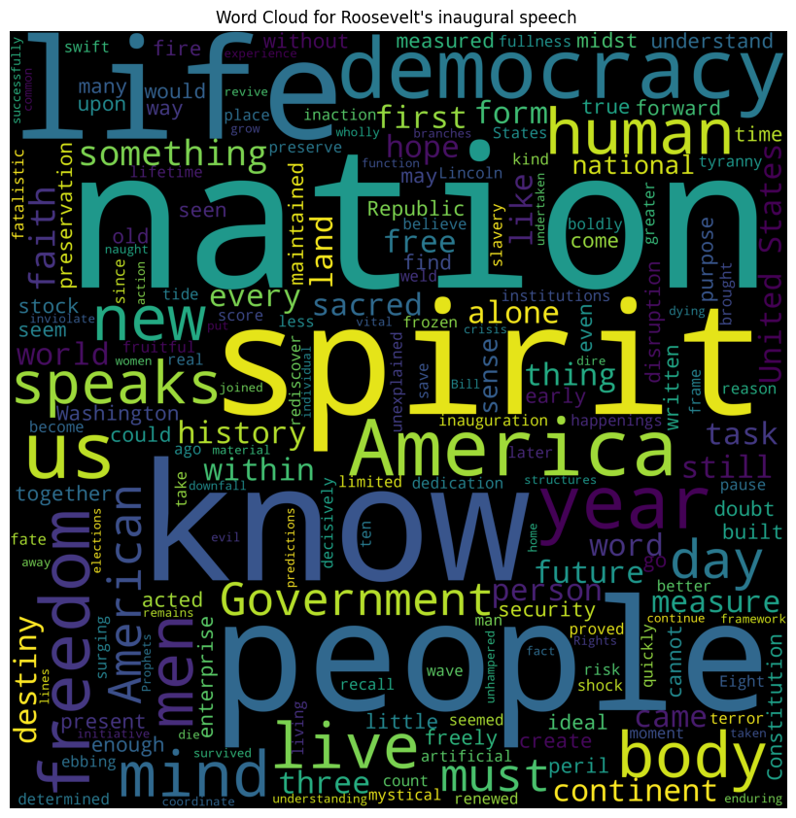

Word Cloud for Kennedy’s speech

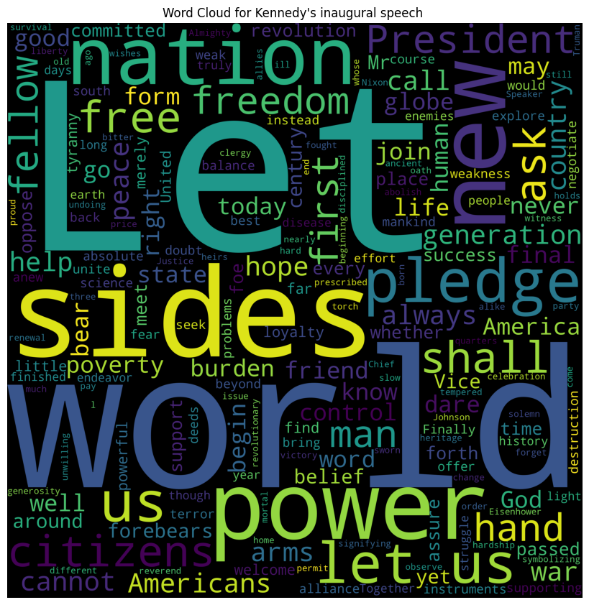

Word Cloud for Nixon’s speech

